Main text of the report (10.5 pt). References should be cited using numbers with square brackets, for instance [1]. The length of this report should not exceed 1 page in A4 format.
Title of the experimental report (14 pt)
A. Author (10.5 pt)A, B. AuthorB, C. AuthorC
AISSP-NSL, Univ. of Tokyo(10.5 pt, italic), BABC Univ., CDEF Institute

[1] A. Author et al., J. Phys. Soc. Jpn. 123, 4567 (2025).

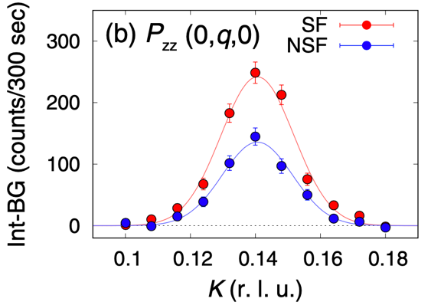
Fig. 1. Figure caption (10.5 pt). It is also possible to put multiple figures in a report.

